SIMATS ENGINEERING
ASSESSMENT TOOL 2

NAME: MONISHVARAN V
REG NO: 192424398
COURSE NAME: Database Management Systems
COURSE CODE: CSA0501

COURSE OUTCOME COVERED

CO1: Analyze DBMS architecture, different data models, schema types, and design
ER/EER diagrams, relational schemas for case-based scenarios by identifying
entities and relationships. (BL1, BL2)

Activity Tool : Concept Mapping (Medium)
Assessment Tool Weightage: 35%

- Concept Map: DBMS, Schema, Instance, Data Model, ER Diagram, Entity, Attribute, Relationship
- DBMS → manages → Schema (blueprint of database)
- Schema → defines → Data Model (structure)
- Instance → actual data → conforms to Schema
- Data Model → represented by → ER Diagram
- ER Diagram → consists of → Entity, Attribute, Relationship
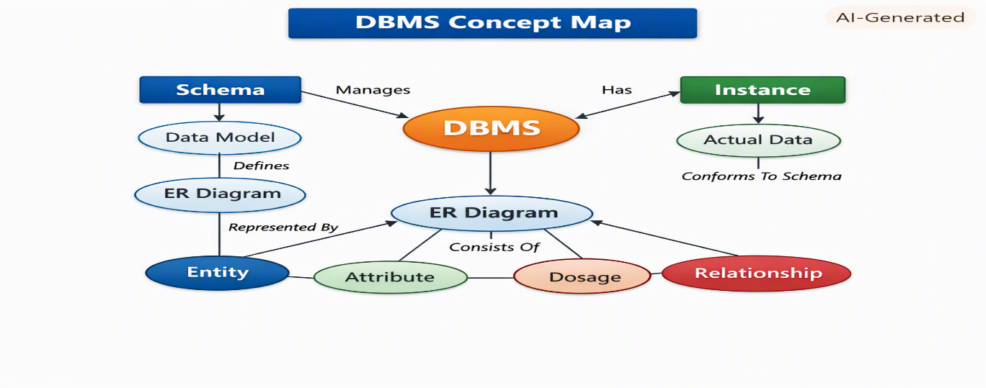
2️⃣ Concept Map: ANSI/SPARC Three-Level Architecture
- External Level (View Schema) → user-specific views
- Conceptual Level (Logical Schema) → overall logical design
- Internal Level (Physical Schema) → storage details
- Data Independence:
  - Logical Independence → change logical schema without affecting views
  - Physical Independence → change physical storage without affecting logical schema
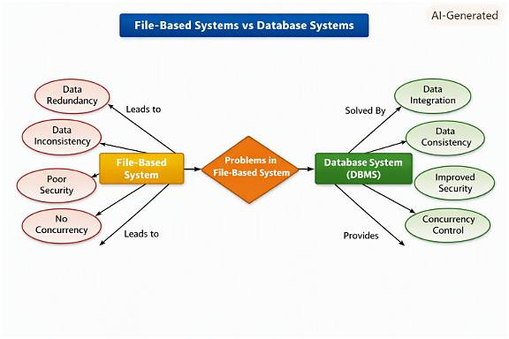

3️⃣ Concept Map: File-Based vs Database Systems
- File-Based System → problems: redundancy, inconsistency, poor security, no concurrency
- DBMS → solves: central control, reduced redundancy, integrity constraints, security, concurrency control
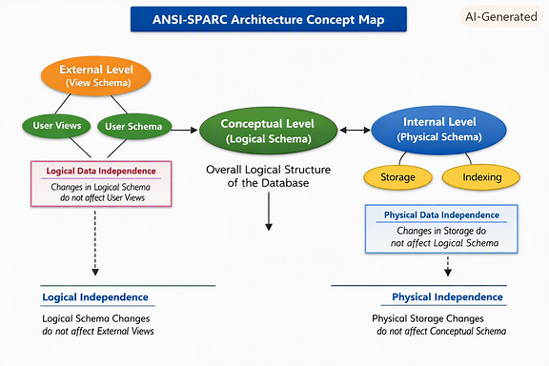
4️⃣ Concept Map: ER Diagram Components
- Entity → strong entity
- Weak Entity → depends on strong entity
- Attributes → simple, composite, derived, multivalued
- Relationships → one-to-one, one-to-many, many-to-many
- Participation Constraints → total vs partial participation
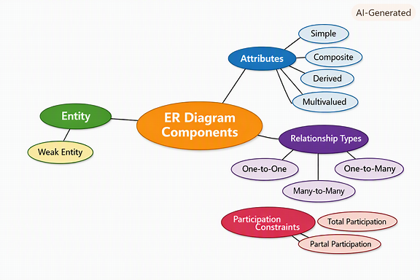
5️⃣ Concept Map: Data Models
- Hierarchical Model → tree structure, parent-child
- Network Model → graph structure, many-to-many links
- Relational Model → tables, rows, columns, keys
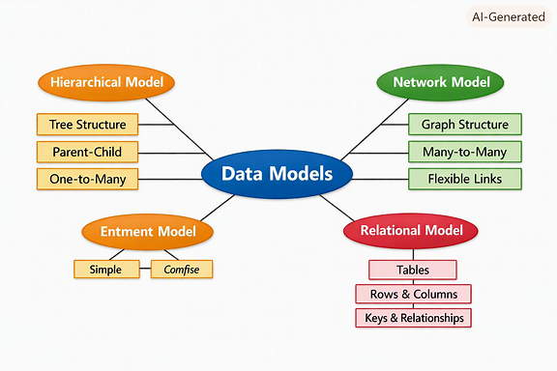
6️⃣ Concept Map: Extended ER (EER) Model
- EER extends ER with:
  - Generalization → combine entities into superclass
  - Specialization → divide entity into subclasses
  - Aggregation → treat relationship as entity
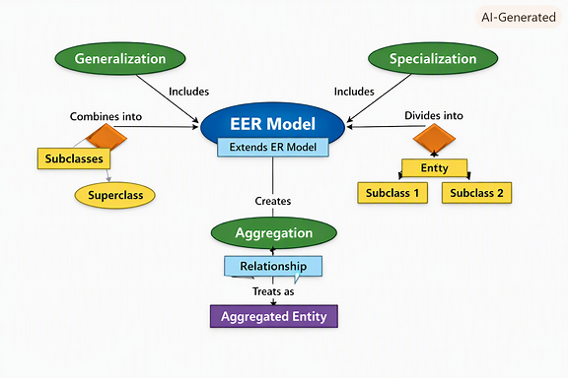
7️⃣ Concept Map: DBMS Software Architecture
- User Request → Query Processor → Execution Engine → Storage Manager → Database → Data Retrieval → User
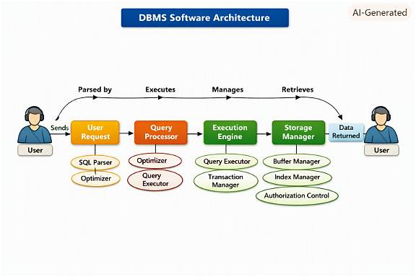

8️⃣ Data Models and Applications ER Diagram
Entities:
- Data Model (Model_ID, Name, Structure_Type)
- Application (App_ID, Name, Domain)
Relationships:
- Used_For → connects Data Model ↔ Application
Example Connections:
- Hierarchical → XML Storage
- Network → Telecom Systems
- Relational → Banking, ERP
9️⃣ Schemas and Instances ER Diagram
Entities:
- Schema (Schema_ID, Type, Description)
- Instance (Instance_ID, Timestamp, Data_State)
- Data Independence (Independence_ID, Type: Logical/Physical)
Relationships:
- Defines → Schema ↔ Instance
- Ensures → Schema ↔ Data Independence
🔟 DBMS Roles and Responsibilities ER Diagram
Entities:
- DBA (DBA_ID, Name, Role, Responsibility)
- End_User (User_ID, Name, Access_Level)
- Application_Developer (Dev_ID, Name, Project)
- Database (DB_ID, Name, Type)
Relationships:
- Manages → DBA ↔ Database
- Uses → End_User ↔ Database
- Develops → Application_Developer ↔ Database
- Supports → DBA ↔ Application_Developer

